Prayer before a Board Meeting

Double ARC
Double ARC serves children with Fetal Alcohol Spectrum disorders (FASD) through education, intervention, and advocacy.

Leader: A Reading from the Charism of the Sisters of Notre Dame

Speaker 1
“As Sisters of Notre Dame we share in the special gifts of the Holy Spirit given to our spiritual mother, Julie Billiart, to our foundress, Hilligonde Wolbring, and to our co-foundress, Elisabeth Kühling. Hilligonde’s charism, a deep experience of God’s provident care, moved her to a compassionate love for others, especially poor children. … Our congregation shares in the charism of Julie Billiart, (namely, her) deep experience of God’s goodness.
Speaker 2
“(Their) charism …a deep experience of God’s goodness and provident care, continues to be enriched by the creative fidelity of each Sister of Notre Dame.”

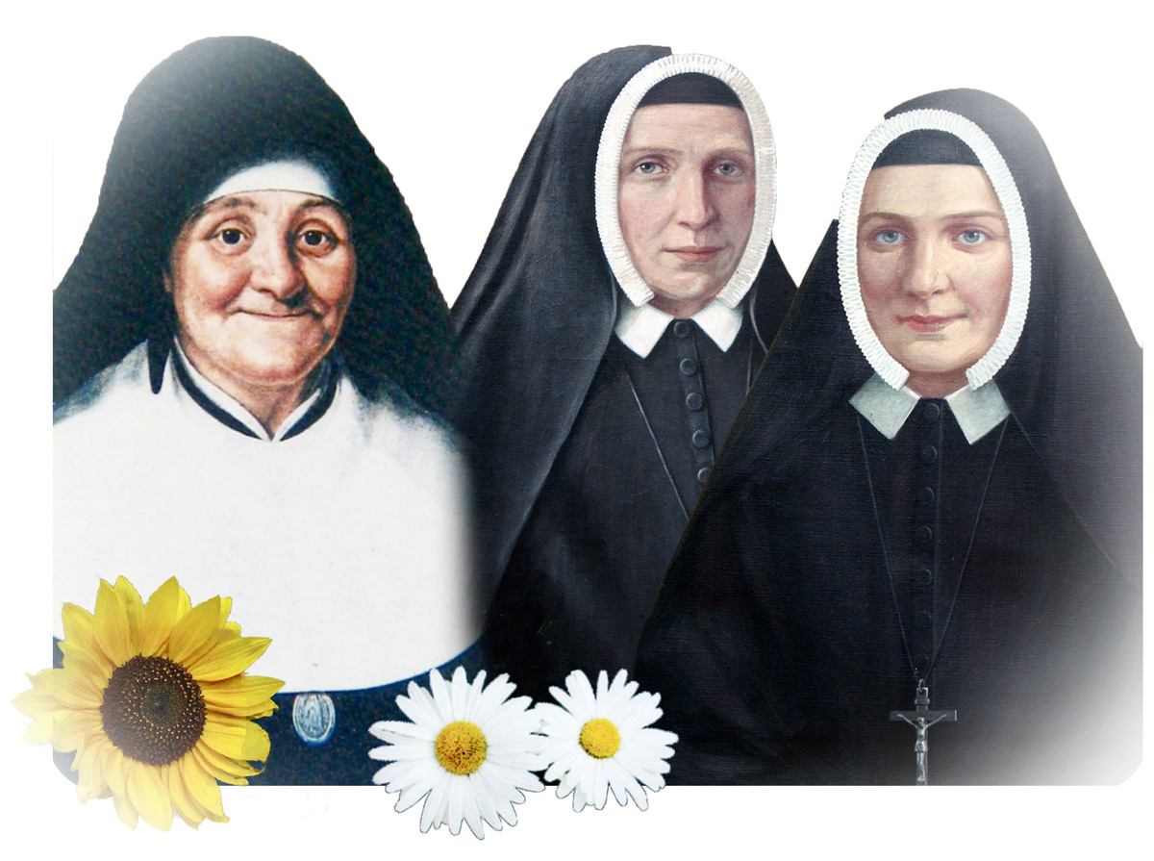

From left, St. Julie Billiart , Elisabeth Kühling, known as Sister Maria Ignatia, and Hilligonde Wolbring, known as Sister Maria Aloysia.

Leader: A reflection on the reading

Two women had deep experiences of God in their lives. One named it as provident care. The other named it as goodness. Today each Sister of Notre Dame lives into this blended charism, bringing her personality, family experiences, spirituality and professional training to bear on her life as a woman religious.
Their creative fidelity has been evident in the work of Double ARC. How would you name some of that creativity, that fidelity?

Leader: Prayer for our work

Good and Gracious God, bless the work of our minds, hearts, and bodies as we meet together. May the purpose of our meeting creatively serve people affected by FASD. We ask the inspiration of your Spirit, and that all be done through your Son, Jesus Christ.
All: Amen.

Article 1, Constitutions of the Sisters of Notre Dame of Coesfeld © Prayer service prepared by Sr Mary Jo Szpila, SND, Toledo Province 2011.

